**EXP NO 15:create a snapshot of a virtual machine (VM) using VMware Workstation on and verify its functionality by reverting to the snapshot or creating and running a cloned VM.**

**Aim:** To create a snapshot of a virtual machine (VM) using VMware Workstation on and verify its functionality by reverting to the snapshot or creating and running a cloned VM.

**Procedure :**

**Step 1: Launch VMware Worksta on**

1. Open VMware Workstation on your system.

2. Select the virtual machine you wish to manage from the le panel.

**Step 2: Shut Down the Virtual Machine**

• Shut down the VM to ensure a clean snapshot (optional but recommended).

**Step 3: Take a Snapshot**

1. Click on the VM menu.

2. Select Snapshot → Take Snapshot.

3. Enter a name (e.g., "Before Update") and an optional description.

4. Click Take Snapshot to save the VM's current state.

**Step 4: Make System Changes (Optional)**

• Start the VM and install so ware or make system changes for testing purposes.

**Step 5: Revert to the Snapshot**

1. Go to VM → Snapshot → Snapshot Manager.

2. Select your previously saved snapshot.

3. Click Go To to restore the VM to that state.

**Step 6: Clone the VM (Optional Alternative)**

1. Shut down the VM again.

2. Go to VM → Manage → Clone.

3. Choose:

o Clone from Snapshot (to use saved snapshot)

o Create a Full Clone (for independent use)

4. Name and save the clone in your desired location.

**Step 7: Run the Cloned VM**

• Power on the cloned VM and verify that it runs as expected, matching the state of the snapshot.

**IMPLEMENTATION:**

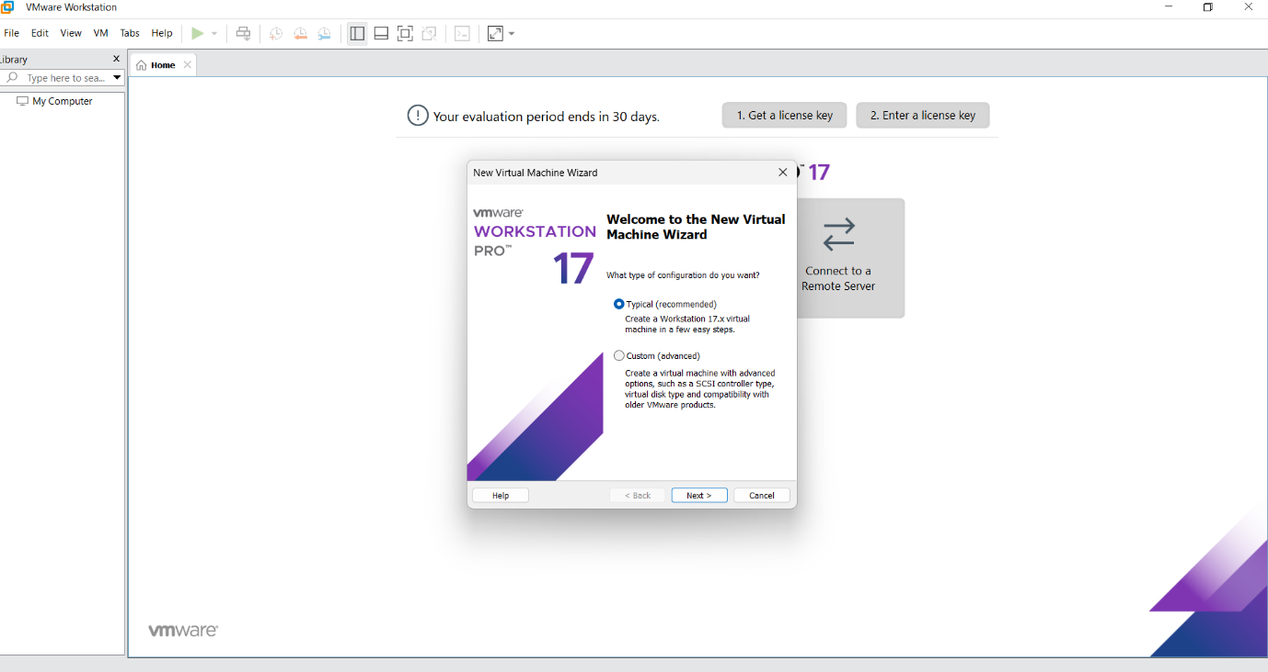

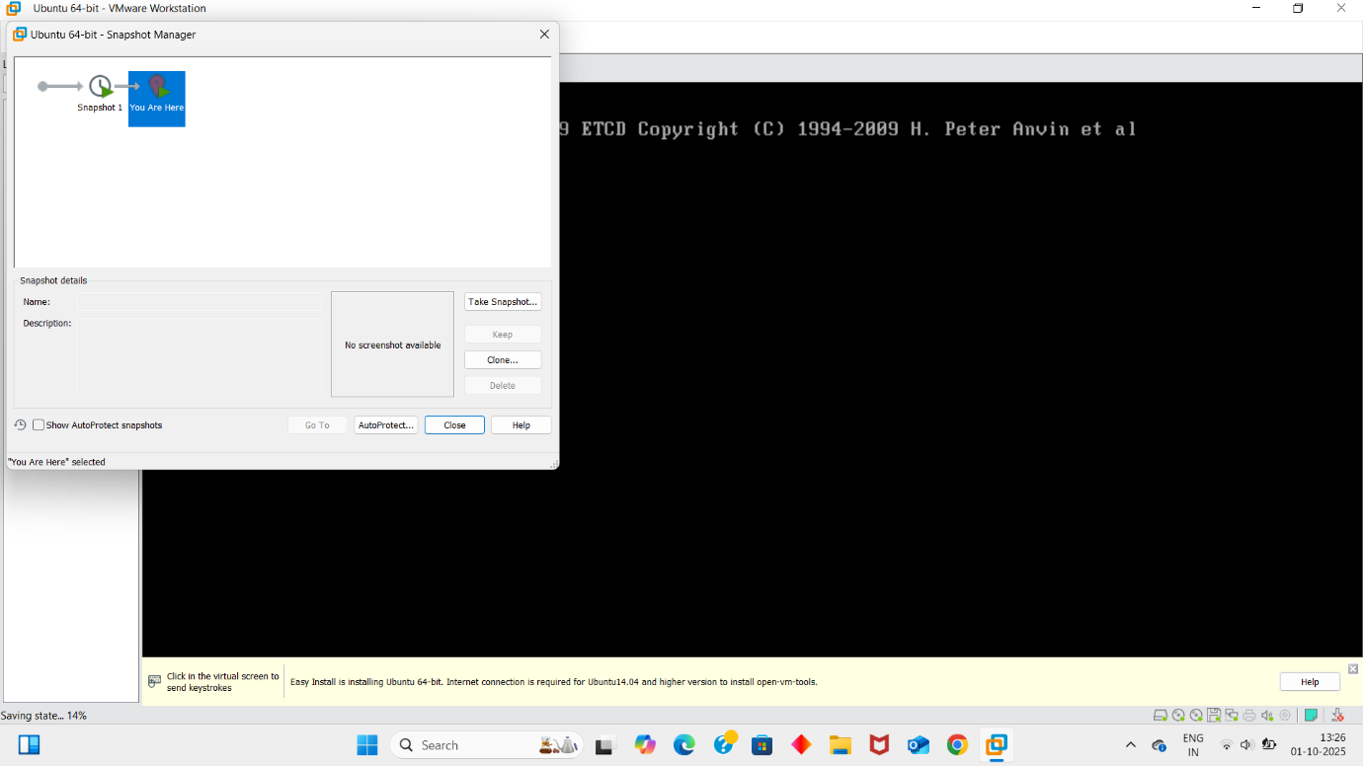

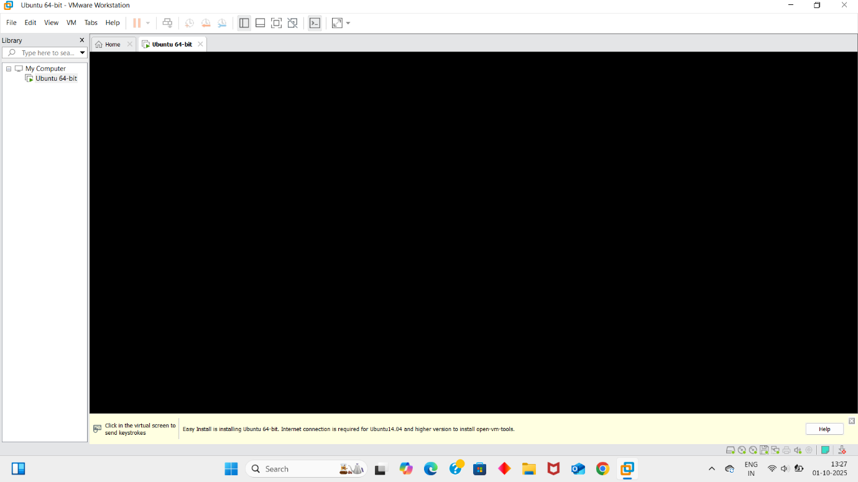

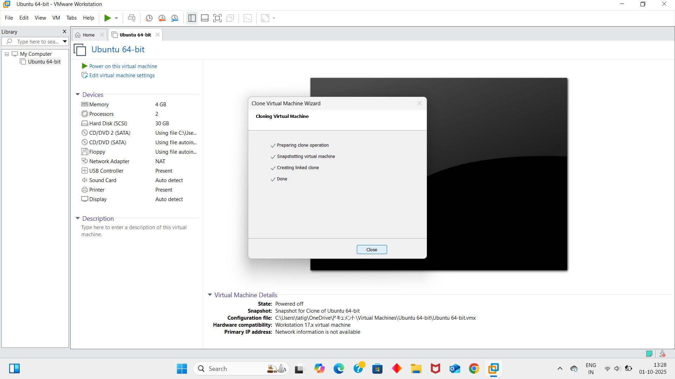

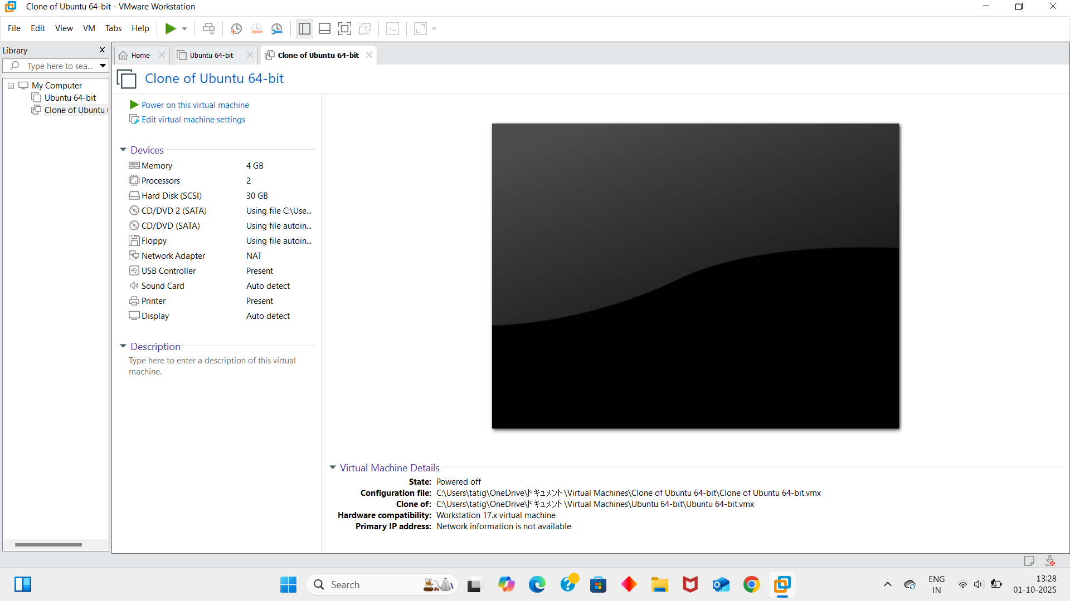

**Result :**

The virtual machine snapshot was successfully created. The system was reverted to the snapshot state without data loss. Additionally, a cloned VM was created and verified to run correctly from the selected snapshot state.